Christ Church CE Primary School
Tel: 234834

Harvest Service

Dear Parents/Carers,

All pupils from Reception upwards will be attending our Harvest Service at church on Tuesday 2nd October at 2.00pm. We would love it if you could join us. Nursery children will not be taking part due to their Bookstart event being held on the same afternoon. All items will be donated to the OPEN DOOR, Stoke-on-Trent, happening every Tuesday at Christ Church.

Having spoken to Fr Tommy, the following food and drink items would be gratefully received:
- Any tinned fruit, vegetables, stews, soups, beans, tomatoes
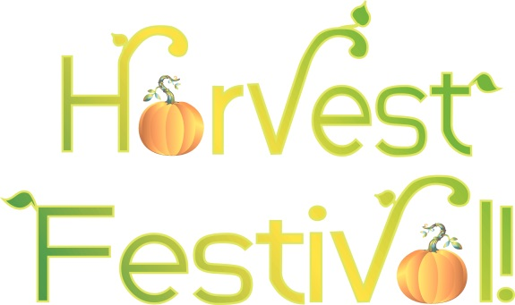
- Dried pasta or rice
- Biscuits
- Tea
- Sugar
- Coffee
- Breakfast cereal
- Long life milk
- Squash

All of the above items can be purchased quite cheaply from local shops and supermarkets. Any donations, no matter how small, really do make a difference. As we are short of space could donations be brought into school on Monday 1st or Tuesday 2nd October.
It would be a pleasure for you to join us as we celebrate Harvest and it would be great if you could help to escort the children to church (please see your child’s class teacher if you are able to). This would be especially helpful with our reception and Year 1 children. Children will be allowed to go home straight from church if they have attended the Harvest Service.

Yours sincerely,
Mrs P Scattergood

