Christ Church CE Primary School
Tel: 234834
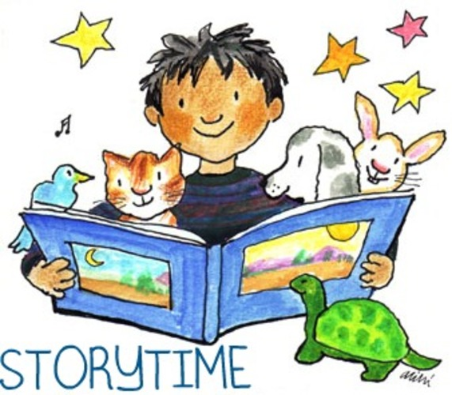
Bookstart Storytime
with
Stoke-on-Trent Library Service

Dear Parents/Carers

On Tuesday 2nd October, a Librarian from the
Stoke-on-Trent Library Service will be visiting our Nursery Class to read stories and rhymes to the children.

We would like to invite you to join your child in the whole class reading session to help emphasise the importance of reading at home.
The session takes place on
Tuesday 2nd October 2018 at 2.15 p.m.

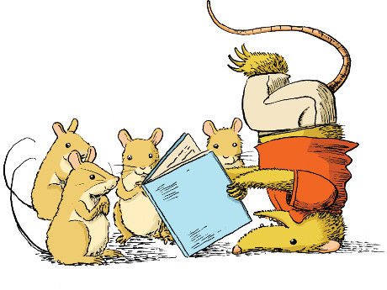
The children will be given a free book to take home.

We look forward to seeing as many parents/carers as possible.

Thank you

Mrs Scattergood

