Tuesday 2nd June 2020

RE: Arrangements for School Re-opening to Pupils in Reception, Year 1 and Year 6 and our existing Key Worker/Vulnerable Children

Dear Parents,

I would like to thank you again for your patience and understanding while we have been working on our plan for the re-opening of school to our reception, year one and year 6 children together with the current children of key workers from 3rd June.

Please note our revised School Opening Hours
- School will be open to our key worker/vulnerable children Monday - Friday between 8.45am and 3.15pm.
- The opening hours Monday – Thursday for our other year groups are:
  - Reception: 9.30am – 2.30pm (outside the reception classroom)
  - Year 1: 9.15am-2.45pm (children will enter through Y3 classroom)
  - Year 6: 9.00am – 3.00pm (children will enter through the Y2 classroom)
- To enable a thorough deep clean at the end of every week, school will close at the following times each Friday:
  - Reception: 12.30pm (outside the reception classroom)
  - Year 1: 12.45pm (children will enter through Y3 classroom)
  - Year 6: 1.00pm (children will enter through the Y2 classroom)
  - Key Worker Children: 3.15pm
All children will have lunch before leaving.

After the completion of a thorough Risk Assessment please find below the preventative measures the school has put in place in order to minimise the spread of infection:
- Displaying coronavirus infection control measures information posters around the school
- Encouraging good hygiene by promoting the importance of handwashing for at least 20 seconds with warm water and soap in the following circumstances:
  - Before leaving home
  - On arrival at school
  - After using the toilet
  - After breaks and sporting activities
  - Before food preparation
  - Before eating any food, including snacks
  - Before leaving school

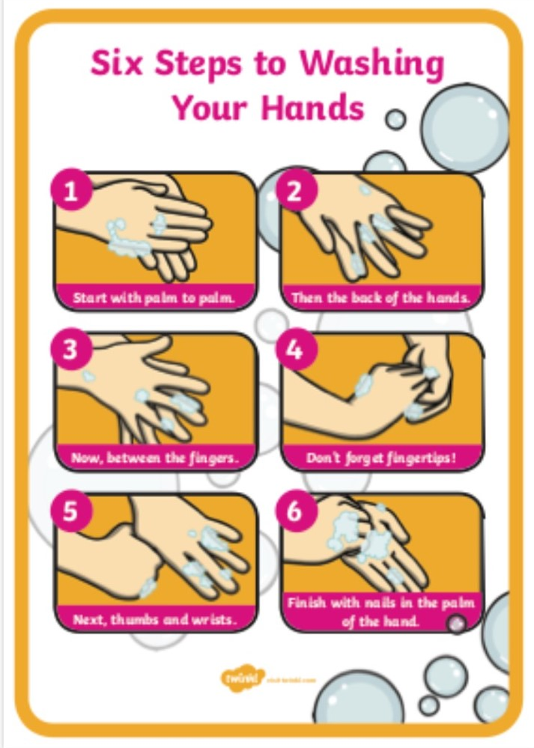

- Having alcohol-based hand sanitiser available throughout the school
- Ensuring pupils and staff understand that they must cover their mouth and nose with a tissue before they cough or sneeze, then throw the tissue away or cough/sneeze into their elbow. Both followed by hand washing.
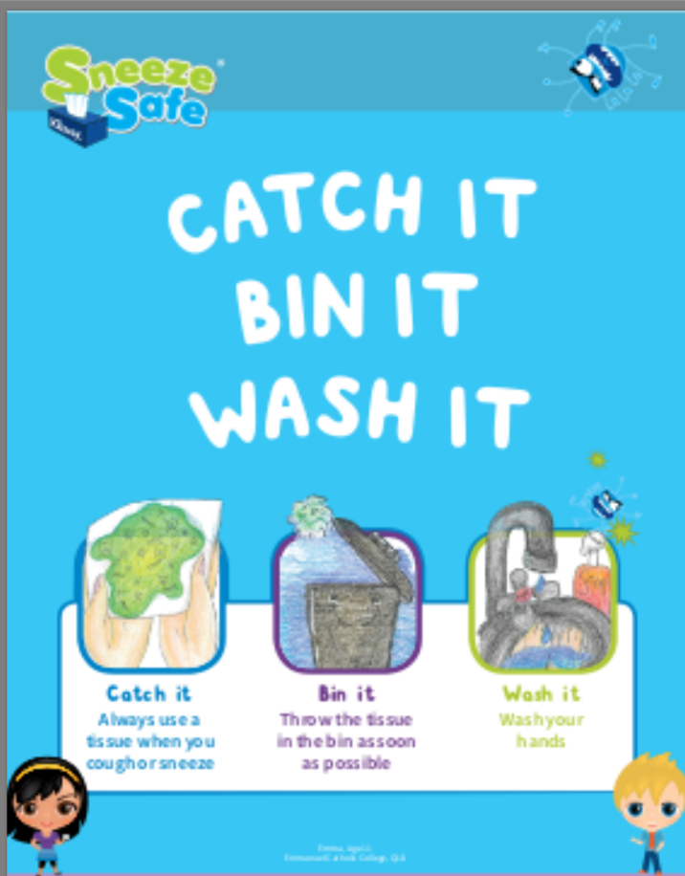

- Ensuring frequently touched objects and surfaces are cleaned and disinfected more regularly than usual
- Telling staff to stay at home for 14 days if they develop symptoms of coronavirus
- Children will be placed in their own ‘bubble’ with the same staff and children each day to greatly reduce the number of people your child will come into contact with each day
- Our classrooms will be following the 2m social distancing rule so will have less than the government recommended 15 pupils
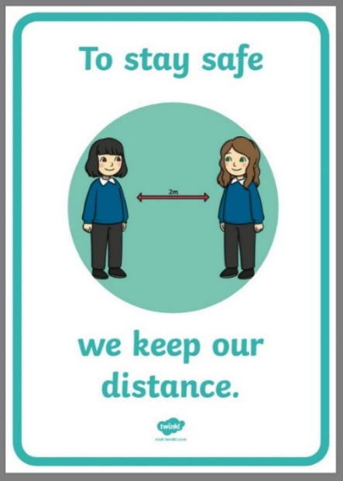
- New behaviour expectations will be in place.
Remember the Rules, Stay Alert and Stay Safe!

In your classroom:
- Only use the resources in your own pack.
- Stay at your desk unless an adult asks you to move- put your hand up if you need help.
- Wash your hands thoroughly when asked to do so.
- Stay in the classroom unless you are with an adult.
- Keep your hands to yourself and do not touch things around the room.
- If you sneeze or cough, use a tissue and then put your hand up and ask to put it in the bin. Wash your hands afterwards or use hand sanitizer.

Around school:
- Use the lines on the floor to help you stay 2m apart.
- Keep to the left hand side of the corridor.
- Only go into the toilets if nobody else is inside.
- Keep your hands off displays and furniture around school.

In the playground:
- Only play in areas that your teachers ask you to.
- Stay 2m apart from your friends- you must not touch each other.
- Use the equipment that your teacher gives to you.
- Wash your hands when you go inside.

To help us maintain social distancing as much as possible, we have made the following changes to the school day:
- The desks have been spaced out in classrooms at distances of 2m from each other and the number of desks has been considerably reduced. Unneeded furniture has been moved out of classrooms wherever possible to create more space in classrooms and less areas to keep clean.

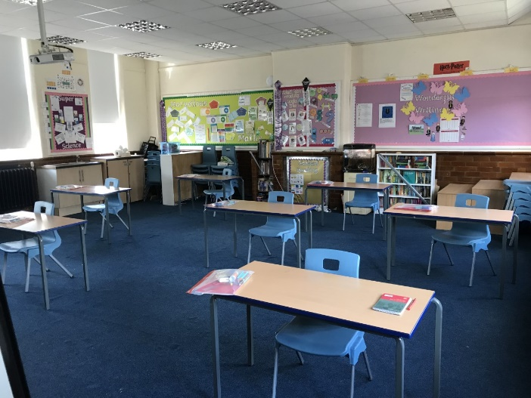

- The corridors has been marked at 2m distances to support social distancing around the school
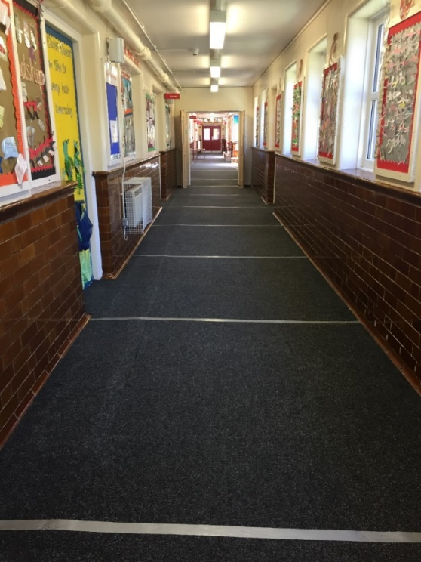

- Children will not leave their designated classroom unless they are accompanied by an adult to reduce the amount of contact with staff and children from other bubbles
- Children will be provided with an individual pack of resources in a zip folder which will be kept on their desk to use throughout the day.
- Children will keep their personal belongings in the classroom under the desk that they are working at. They will only need to bring a school bag, a coat (weather depending), hat, sunglasses, large umbrella for sunshade, their snack for break, a full water bottle and their lunch if they are bringing a packed lunch. They do not need to bring anything else.
- Children do not need to bring their reading book into school, they will be provided with reading activities in school.
- Younger children will be encouraged as much as possible to stay at their own desks when working in classrooms and when lining up, to stay 2m apart.
- There will be no whole school worship or other occasions where bubbles/groups will congregate together.
- If we need to administer first aid or medication staff will wear PPE.
- If you need us to administer medication to your child please make sure all information has been passed on to school via text or email principal@christchurchfenton.co.uk so that we have written evidence. Please state the name of your child, dosage and time the medicine needs to be administered.
- All communication with school needs to be made via text, dojo, email or telephone. If we do not have an email address contact could you please text, dojo or email this to principal@christchurchfenton.co.uk

How you can help us minimise the spread of infection
- Ensure that you are following government guidance, https://www.gov.uk/coronavirus especially around socially distancing and good infection control practices. If you cannot follow this guidance, please do not send your child to school as this would be an additional risk for children and staff in school. If we have evidence that these guidelines have not been followed your child will not be allowed in school.
- If your child has any covid-19 symptoms DO NOT send them to school. You should arrange for them to be tested and keep your child at home for a period of 14 days if they develop coronavirus symptoms. More information regarding symptoms and actions can be found on the NHS website (https://www.nhs.uk/conditions/coronavirus-covid-19/). It is essential that if you think your child may have been exposed to or has coronavirus, please contact the school on 01782 234834 at the earliest opportunity.

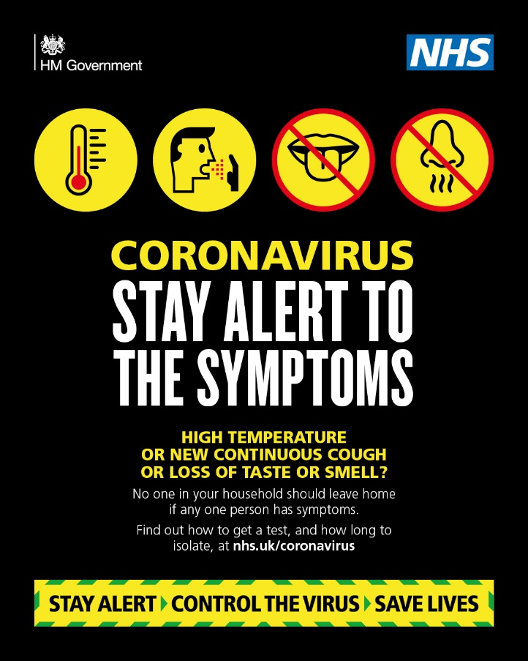

- Send your child to school in clean clothes each day – non-school uniform. Children will need to wear sensible shoes or trainers - no flip flops, open toe shoes or wheelies please.
- The wearing of facemasks by children in school will not be allowed as these could increase the spread of infection rather than reduce it.
- To reduce the number of people using the reception area, if you need to communicate with office staff or teachers, we would ask that you please contact them on the main school telephone number. Alternatively use the school text service or class dojo. We want to dramatically reduce the number of face to face visitors to minimise the risk of the infection spreading.
- Notify us as soon as possible of any medical needs that your child has which could make them vulnerable to an infection.

Arrangements for the start and end of the school day
- We encourage pupils to walk or cycle to school if possible and avoid public transport where possible.
- Pupils/families will enter the school via William Street and leave via our Manor Street exit. This will create a one-way system to avoid potential bottlenecks on our playground.

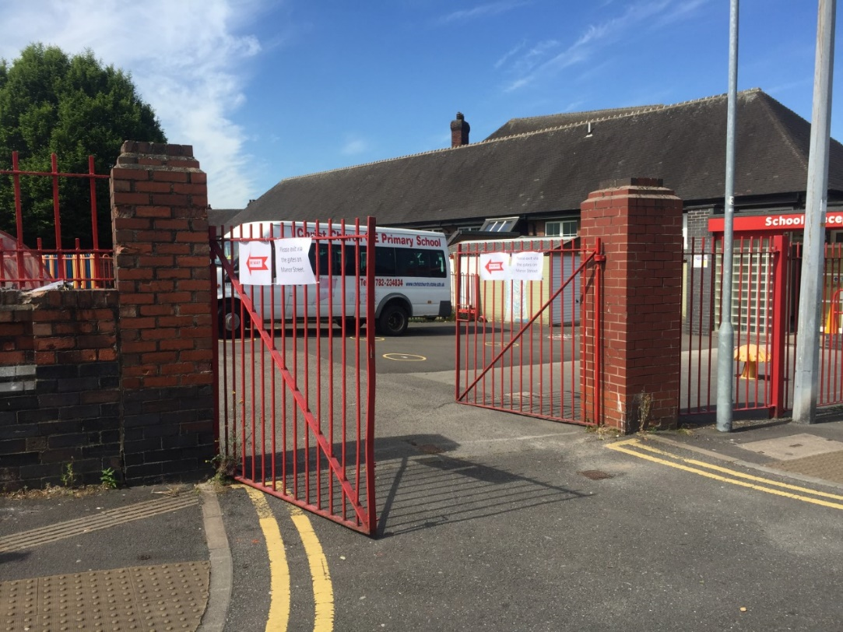
Pupils will enter via the double gates on the playground on William Street

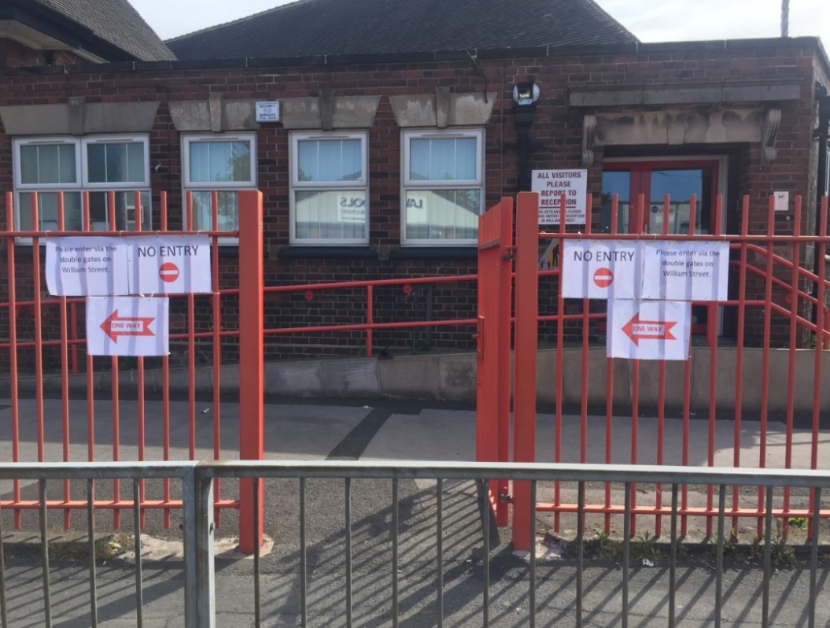
Pupils will exit via the gate on the playground on Manor Street
- The times for dropping off and picking up pupils will be staggered for each year group as follows:
  - Reception: 9.30am – 2.30pm (outside the reception classroom)
  - Year 1: 9.15am-2.45pm (children will enter through Y3 classroom)
  - Year 6: 9.00am – 3.00pm (children will enter through the Y2 classroom)
  - Key worker children: 8.45am-3.15pm (children will enter via the main school office)
- Do not arrive at school before your child’s starting time or collecting time as we do not want families congregating on the playground.
- As soon as children have been left or collected please leave the school site via the Manor Street entrance.
- Please keep a 2metre distance from all other parents and children when on the site. Only ONE adult should enter the school grounds to drop off and collect children per family.

Arrangements for break-times and lunch-times
- Lunch and break times will be on a rota basis for each group of children.
- Toast will not be available so we are allowing children to bring in a healthy snack which they can open themselves to eat at break-time.
- Please provide your child with a full water bottle each day that they will need to take home and bring back each day. Cups will not be available in school.
- Children will stay within their small ‘bubble’ as far as possible throughout break times and will have a section of the playground assigned to their group on a timetable so they do not need to mix with other groups at playtimes and lunchtime.
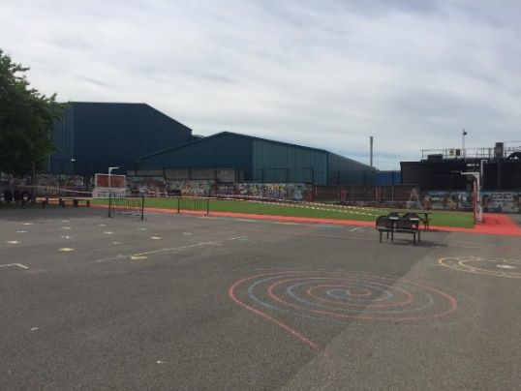
- Each group will have a selection of resources that they can play with which will be cleaned after each session. No games, balls or toys can be brought into school from home.
- Packed lunches and school lunches will be eaten in the classrooms that children are working in and for school lunches, disposable plates and disposable cutlery will be used.
- Dinner money MUST be paid weekly every Monday with the exact money as no change will be given. This needs to be brought to school in a clearly labelled envelope or plastic bag stating who the lunch is for. If we do not receive the money on a Monday we will not be able to provide your child with a lunch that week.

Other Important Information
- Where possible the children will be learning outside. Children will need sunhats/caps, sunglasses and a large umbrella which can be used as a sunshade. Can you please make sure sunscreen has been applied before your child comes to school to keep them safe when learning or playing out-doors. We cannot apply this to children in school.
- Please make sure that we have at least two different telephone numbers for your child so we can contact you in an emergency.

As you will appreciate, our plans may change as we continually review our risk assessment and receive further guidance. We will endeavour to keep you updated on any changes.
I hope that these arrangements provide you with some of the information you need to support your child’s return to school. If you would like to speak to somebody regarding anything you have read in this letter please do not hesitate to telephone the school, send a text or message via Class Dojo. I would like to take the opportunity to thank you for supporting the school over recent weeks and supporting your child with their home learning. Seeing the photos of their work on Class Dojo has been wonderful.

Yours sincerely,

Mrs Scattergood

