Tuesday 14th July 2020

Full School Opening in September 2020

Dear Parents,

As you will all be aware, we will all be back to school in September! It seems like such a long time since we saw everyone in school and we are very much looking forward to welcoming you all back on 2nd September.

In order to keep everyone safe, we have completed a thorough risk assessment and, as a result of this, there will be some changes to the school day which are outlined below. It will be very important that we all follow the guidance as closely as possible when we return.

It is important to say that, hopefully, these changes will not be forever and will only be in place as long as they are needed and, if government advice changes, we may need to adapt them further and will endeavour to let you know of any changes in a timely fashion.

The classes will be split up into 4 bubbles to reduce the contacts that children have with each other. All staff are able to work within any bubble although we have tried to limit the number of adults working within each bubble where possible. They will be as follows:
- Nursery and Reception – Early Years Bubble
- Year 1 and Year 2 – Key Stage 1 Bubble
- Year 3 and Year 4 – Lower Key Stage 2 Bubble
- Year 5 and Year 6 – Upper Key Stage 2 Bubble

To follow government guidance on reducing the number of parents and children on the site at any one time, we will be implementing staggered start and finish times which will be as follows:
  - Nursery: 8.55am-2.55pm
  - Reception: 8.55am-2.55pm
  - Year 1: 8.45am-3.05pm
  - Year 2: 8.45am-3.05pm
  - Year 3: 8.40am-3.15pm
  - Year 4: 8.40am-3.15pm
  - Year 5: 8.35am-3.20pm
  - Year 6: 8.35am-3.20pm
We understand that the staggered drop off times will mean that you may need to enter and leave the premises more than once but we ask for your understanding at this time. We want to ensure that you, your child and our staff are kept as safe as possible and we know that you will support us with this.

Arrangements for the start and end of the school day
- We encourage pupils to walk or cycle to school if possible and avoid public transport where possible.
- Pupils/families will enter the school via William Street and leave via our Manor Street exit. This will create a one-way system to avoid potential bottlenecks on our playground.
- In the morning, KS2 children will need to be dropped off at the school gate in the morning and will be supervised as they walk to class by members of staff. Children in EYs and KS1 can be dropped off at the gate or escorted to the classroom by one parent.
- At the end of the day, all pupils will need to be picked up from:
  - Nursery – by the gate onto EYs playground on this one and reception
  - Reception - by the gate onto EYs playground on this one and reception
  - Year 1 – children’s entrance
  - Year 2 – outside classroom door
  - Year 3 – outside classroom door
  - Year 4 – outside classroom door
  - Year 5 – children’s entrance
  - Year 6 – Year 2 classroom outside door
They will then leave the premises following the one way system. Year 6 children will be
allowed to walk home on their own as long as we have written permission from a parent.

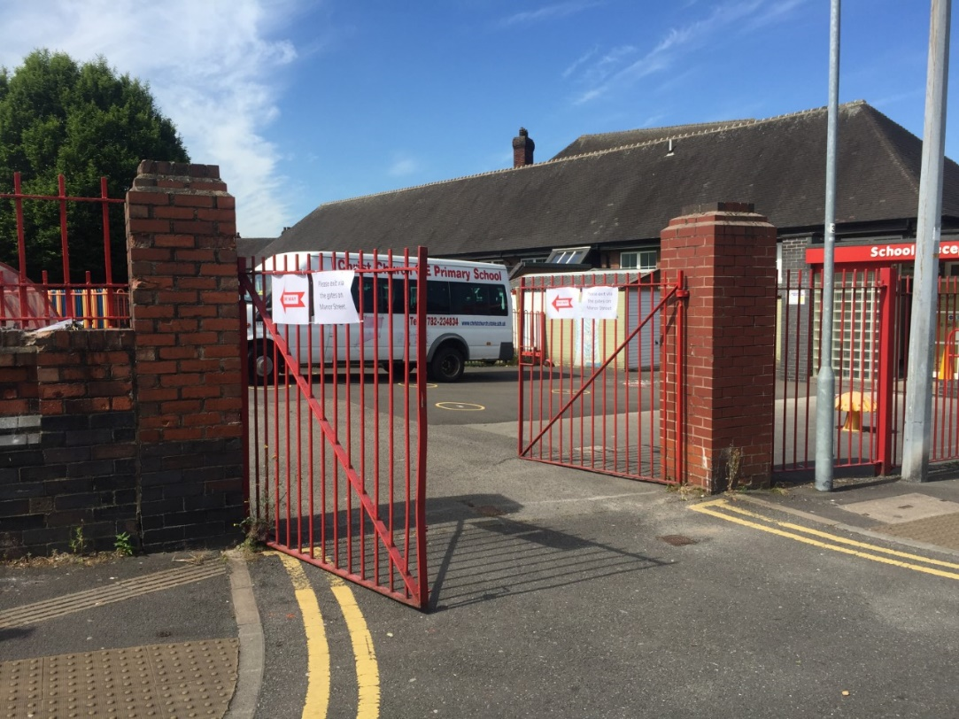
Pupils will enter via the double gates on the playground on William Street

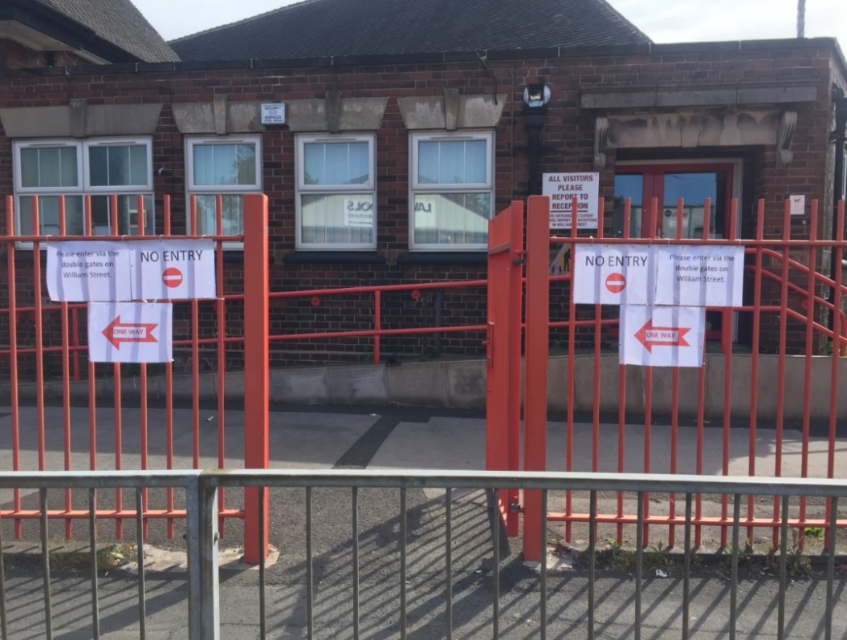
Pupils will exit via the gate on the playground on Manor Street
- Please do not arrive at school before your child’s starting time or collecting time as we do not want families congregating on the playground. Parents will be expected to keep a 2m distance from other families and leave the site immediately after collecting their child.
- As soon as children have been left or collected, please leave the school site via the Manor Street entrance.
- Please keep a 2metre distance from all other parents and children when on the site. Only ONE adult should enter the school grounds to drop off and collect children per family.

Please find below some of the preventative measures the school has put in place in order to minimise the spread of infection:
- Displaying coronavirus infection control measures information posters around the school
- Encouraging good hygiene by promoting the importance of handwashing for at least 20 seconds with warm water and soap in the following circumstances:
  - Before leaving home
  - On arrival at school
  - After using the toilet
  - After breaks and sporting activities
  - Before food preparation
  - Before eating any food, including snacks
  - Before leaving school

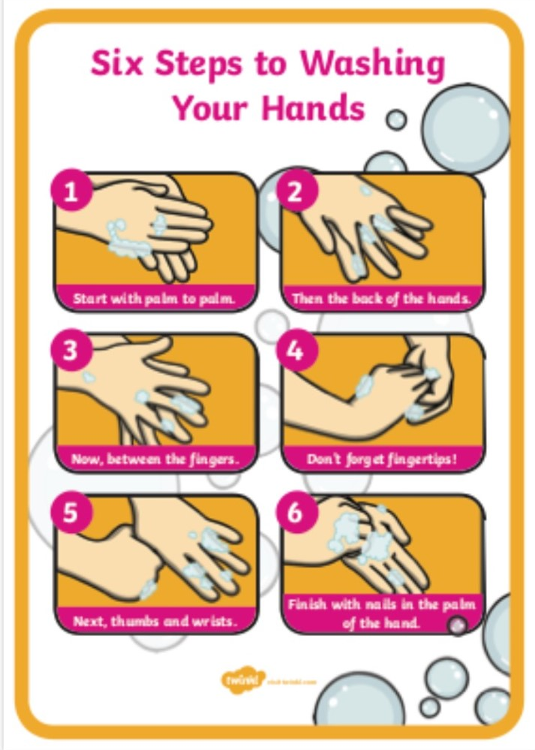

- Having alcohol-based hand sanitiser available throughout the school
- Ensuring pupils and staff understand that they must cover their mouth and nose with a tissue before they cough or sneeze, then throw the tissue away or cough/sneeze into their elbow. Both followed by hand washing.

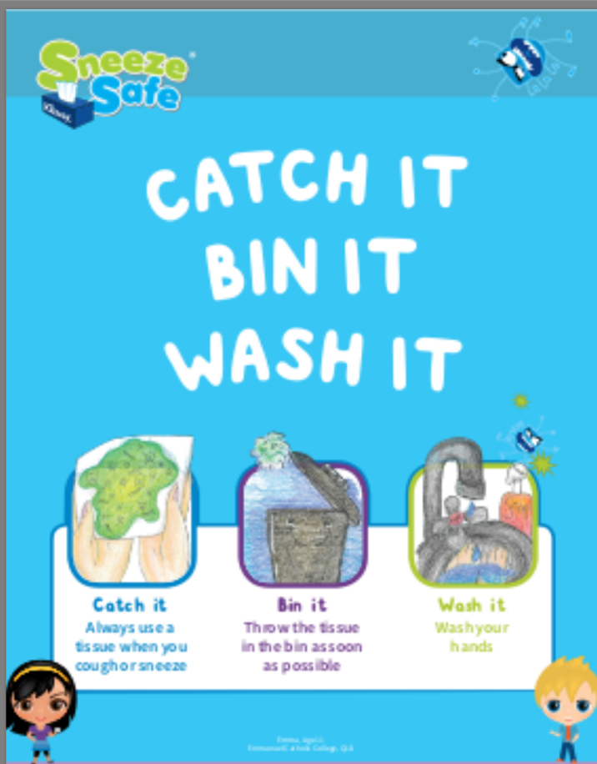

- Telling staff to stay at home for 14 days if they develop symptoms of coronavirus
- New behaviour expectations will be in place.
- Children will be provided with an individual pack of resources in a zip folder which will be kept on their desk to use throughout the day.
- Children will keep their personal belongings in the classroom under the desk that they are working at. They will only need to bring a school bag, a coat (weather depending), their snack for break, a full water bottle and their lunch if they are bringing a packed lunch. They do not need to bring anything else.
- Children will be provided with a reading book and asked to bring it into school on a specific day for it to be changed - more details will follow.
- There will be no whole school worship or other occasions where bubbles/groups will congregate together.
- If we need to administer first aid or medication, staff will wear PPE.
- If you need us to administer medication please contact the school office to arrange for the completion of the relevant forms. Medication should be taken to the school office and NOT sent into school with your child.
- All communication with school needs to be made via text, dojo, email or telephone. If we do not have an email address contact for you, could you please text, dojo or email this to adminteam@christchurchfenton.co.uk

How you can help us minimise the spread of infection
- Ensure that you are following government guidance, https://www.gov.uk/coronavirus especially around socially distancing and good infection control practices. If you cannot follow this guidance, please do not send your child to school as this would be an additional risk for children and staff in school. If we have evidence that these guidelines have not been followed your child will not be allowed in school.
- If your child has any covid-19 symptoms DO NOT send them to school. You should arrange for them to be tested and keep your child at home for a period of 14 days if they develop coronavirus symptoms. More information regarding symptoms and actions can be found on the NHS website (https://www.nhs.uk/conditions/coronavirus-covid-19/). It is essential that if you think your child may have been exposed to or has coronavirus, please contact the school on 01782 234834 at the earliest opportunity.

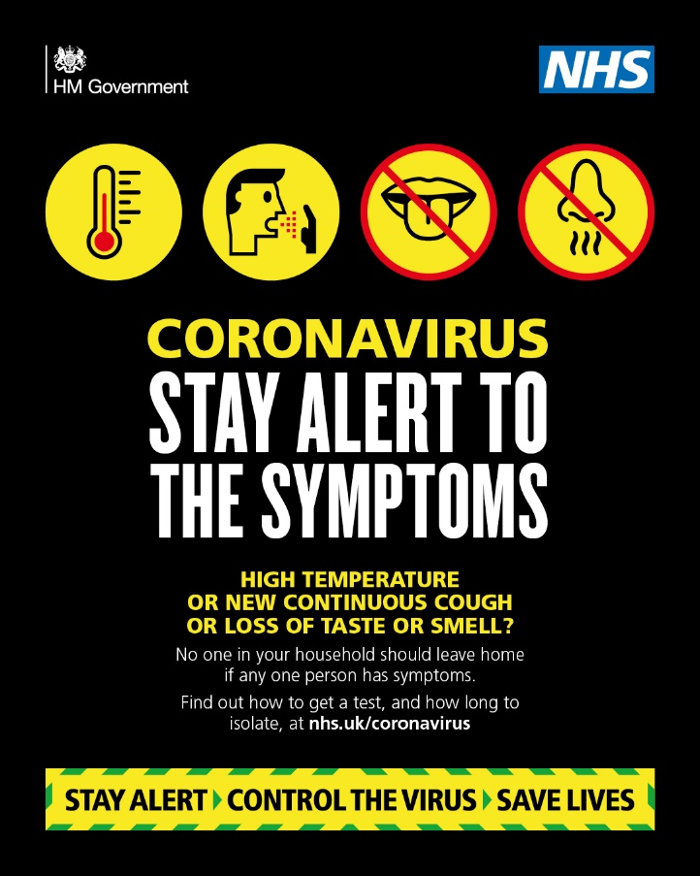

- We will be expecting all children to be wearing full school uniform - NO TRAINERS
- The wearing of facemasks by children in school will not be allowed as these could increase the spread of infection rather than reduce it.
- To reduce the number of people using the reception area, if you need to communicate with office staff or teachers, we would ask that you please contact them on the main school telephone number. Alternatively use the school text service, class dojo or adminteam@christchurchfenton.co.uk email address. We want to dramatically reduce the number of face to face visitors to minimise the risk of the infection spreading.
- Notify us as soon as possible of any medical needs that your child has which could make them vulnerable to an infection.

Arrangements for break-times and lunch-times
- Lunch and break times will be on a rota basis for each group of children.
- Toast will be on sale at break-time every day but this will need paying for every Monday as we will not be collecting money from the children on a daily basis.
- Please provide your child with a full water bottle each day that they will need to take home and bring back each day. Cups will not be available in school.
- Children will stay within their small ‘bubble’ as far as possible throughout break times and will have a section of the playground assigned to their bubble on a timetable so they do not need to mix with other groups at playtimes and lunchtime.
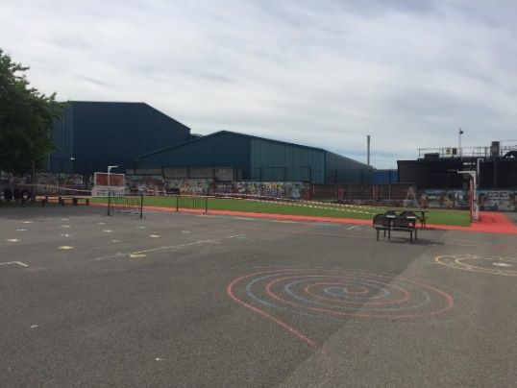
- No games, balls or toys can be brought into school from home.
- Dinner money MUST be paid weekly every Monday with the exact money as no change will be given. This needs to be brought to school in a clearly labelled envelope or plastic bag stating who the lunch is for. If we do not receive the money on a Monday we will not be able to provide your child with a lunch that week.

Other Important Information
- On hot days, children will need sunhats/caps, sunglasses and a large umbrella which can be used as a sunshade. Can you please make sure sunscreen has been applied before your child comes to school to keep them safe when learning or playing out-doors. We cannot apply this to children in school.
- If the weather is cooler or it is raining lightly, please make sure your child has a coat as we will try to ensure that the children spend some time outside each day.
- Please make sure that we have at least two different telephone numbers for your child so we can contact you in an emergency.

As you will appreciate, our plans may change as we continually review our risk assessment and receive further guidance. We will endeavour to keep you updated on any changes.
I hope that these arrangements provide you with some of the information you need to support your child’s return to school. We understand that many of our children have been off school for a considerable period of time and we want to reassure you that we will do all that we can to support them to get back into the school routine on their return. Please let us know if you think your child will be anxious about their return to school so that we can work with you to help support a successful return. If you would like to speak to somebody regarding anything you have read in this letter, please do not hesitate to telephone the school, send a text or message via Class Dojo.

I would like to take the opportunity to thank you again for supporting the school over recent months and supporting your child with their home learning. Seeing the photos of their work on Class Dojo has been wonderful.

Yours sincerely,

Mrs Scattergood

